Comments on the model from the auto.arima()

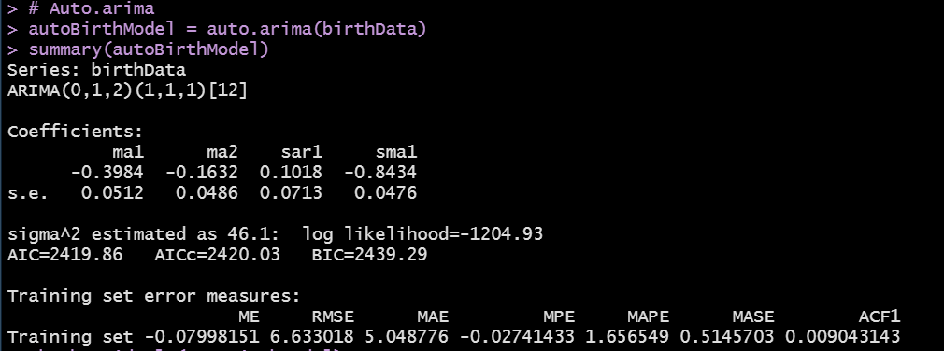

* ARIMA(p=0, d=1, q=2) (P=1, D=1, Q=1)[m=12]
  + Typical MA(2) model on the first differences
  + A Seasonal Arima model fit on the first seasonal differences
    - AR component (1), which means that the lag12 autoregressive coefficient is included
    - MA component(1), means that error correlations are lagged by 12 months
    - D = 1, we are using the first seasonal differences to attain stationarity in the seasonal arima model.